Song management

Technology :-

Fronted : - Reactjs ,applo GraphQL

backed : - mlab(mongoDB) live database

Project Description : -

- User can add song detail
- User can also add lyrics on particular song
- User can like a lyrics
- User can also delete song detail from database
- User can update for particular song

  - user will add the song name :
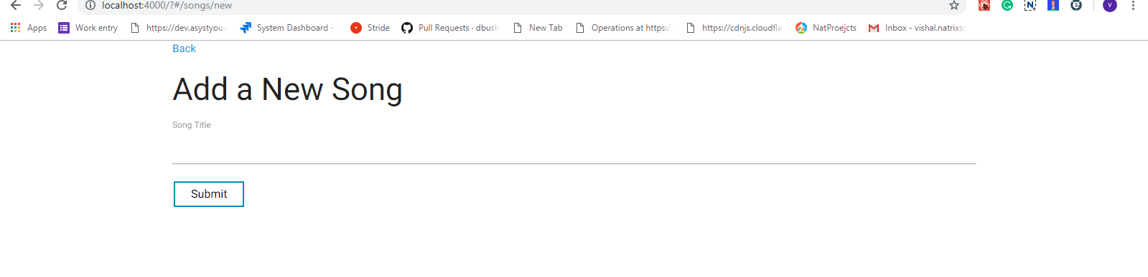
  - when user add a song after that song list will be display
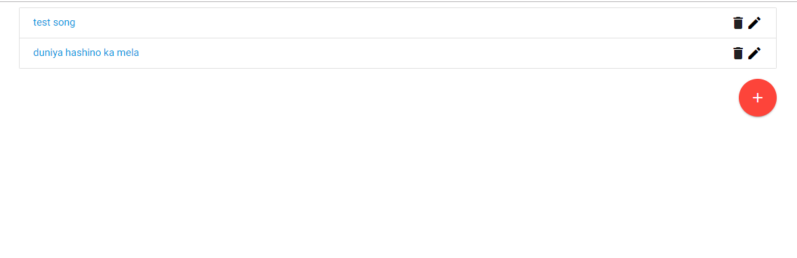

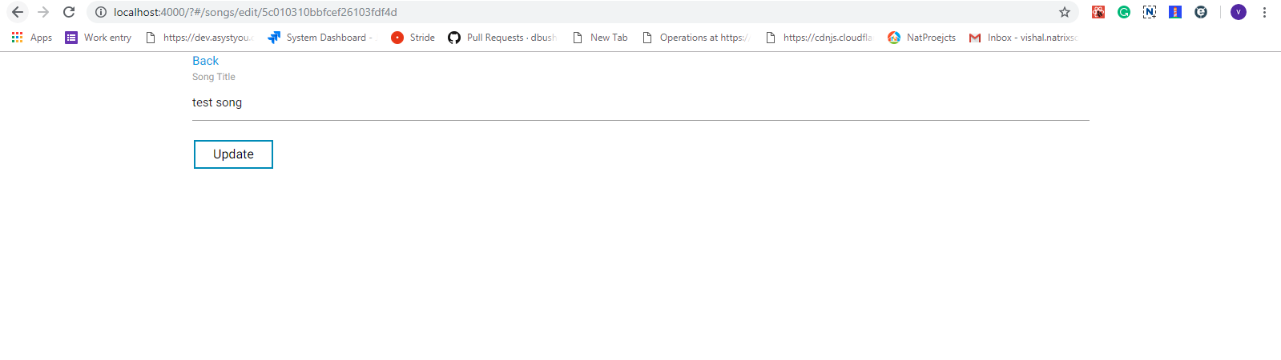
- User can also update particular song.

- when we click on a song we can also add a lyrics of particular song

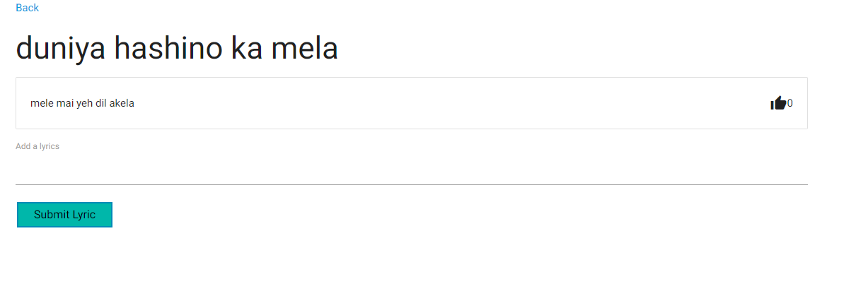
- user can also like a particular song.

